Practical applications of sensory and behavioral biology
Data Interpretation Exercise

During Class
In Season 1, Episode 2 of The Animal Behavior Podcast, Amy speaks with Esteban Fernandez-Juricic, who specializes in visual ecology, behavioral ecology, and conservation biology, as well as the interactions between them. In this exercise, you will be having a look at the results from one of his lab’s papers led by Megan Doppler. The paper focuses on bird strikes (the collision between birds and aircraft) - a harmful human-wildlife interaction - and how sensory biology could be used to reduce the frequency of such events. They wanted to find out what kind of light stimulus would be most visible to the Brown-headed Cowbird (a species known to be involved in bird strikes). The aim would be to use whichever stimulus worked best as a warning light to deter birds from flying closely to airplanes and reduce collisions. A genius way to apply sensory and behavioral biology to address a real-life problem!
For this study, they tested how cowbirds behaved in response to three different visual stimuli: a remote controlled aircraft with either continuous light, pulsing light or lights off. The behaviors measured included latency to alert (time taken to show behavior indicating awareness) and the probability of showing alert behavior within 30 s in response to a remote controlled aircraft. Two graphs used in the paper to show the results are on the following page.
Study the graphs and answer the questions below. Try to phrase your answers as you would expect to see in a scientific paper.
- What does graph A show you?
- What does graph B show you?
- If you were to analyze this type of data, what approach might you take? Think about what are the response variables and what are the predictor variables. Also consider the type of data collected – was it continuous? Discrete?
- What are the implications of these results?
- What would you do next if this was your study? Is there any data you would have collected as part of this study to improve it? What experiment would you want to do next to move the research forward?

After Class
Listen to Season 1, Episode 2 of The Animal Behavior Podcast, in which Amy speaks with Esteban Fernandez-Juricic. His lab lead the study that you just analysed the data for so hear the answers to this exercise from the expert! You can also check out the paper here and read about his lab’s more recent work on this fascinating topic here.
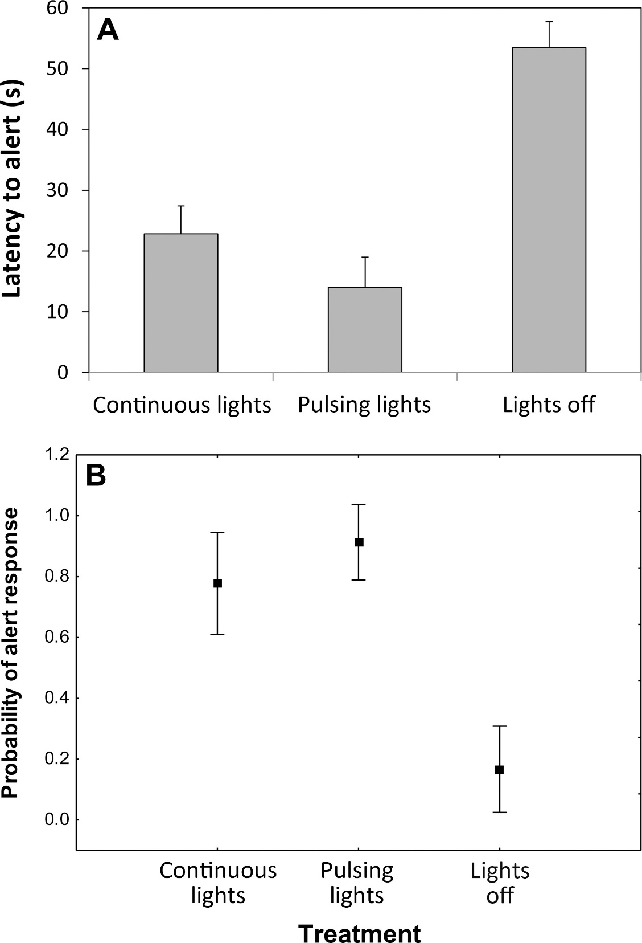
Figure 2. Cowbird (A) latency to alert (higher values indicate more delayed responses) and (B) probability of showing alert behavior within 30 s in response to a stationary RC aircraft under different treatments: aircraft with continuous lights, pulsing lights, and lights off.

Condor, Volume 117, Issue 2, 1 May 2015, Pages 165–177, https://doi.org/10.1650/CONDOR-14-157.1
© 2015 Cooper Ornithological Society

